FSC-20007 Forensic Anthropology and Taphonomy
Scatter Practical

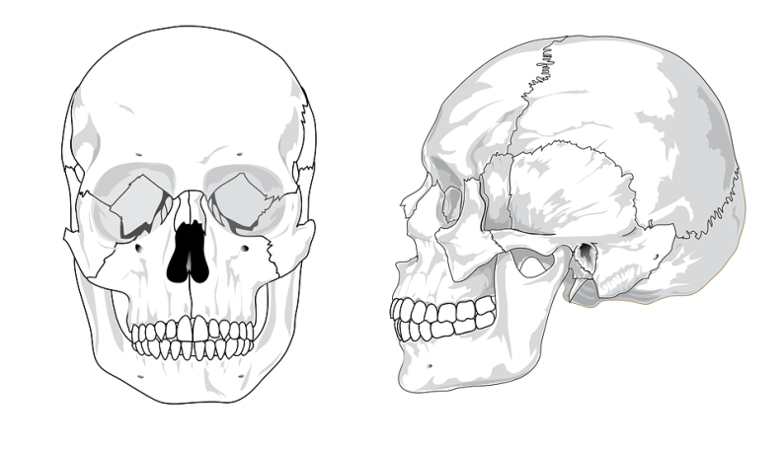
Skull
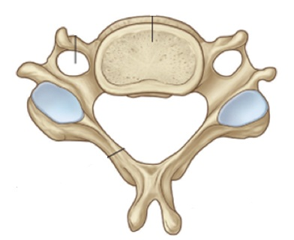

Vertebra
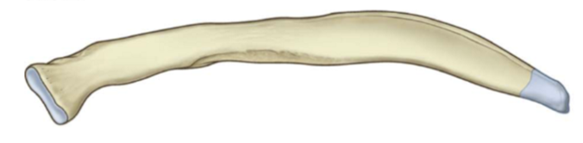
Rib
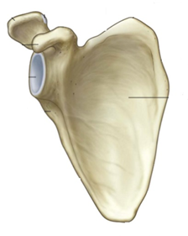

Scapula

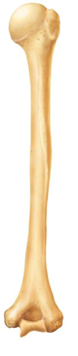

Humerus
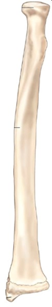
Radius
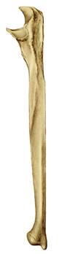
Ulna

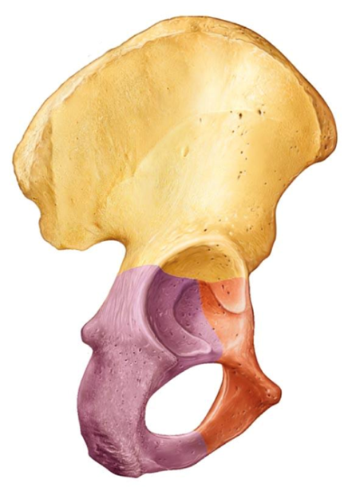
Innominate (pelvis)

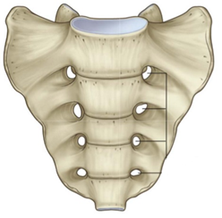

Sacrum

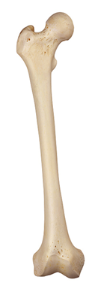

Femur
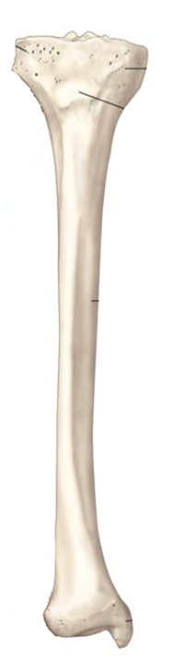

Tibia
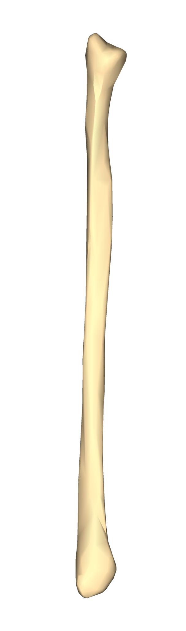
Fibula
Datum point (sketch here) | Direction from baseline:  Distance from baseline:

