

Method Statement

Mass Grave Investigation of Keele campus, Staffordshire

Dated : 25 February 2025
MS – mass grave 2025.docx

A student,
William Smith Building,
Keele University,
Newcastle-Under-Lyme,
Staffordshire,
United Kingdom,
ST5 5BG

Prepared By: | A Student |  | Checked By: | Student’s boss
Sign: |  |  | Sign:
Contents

1. Project Overview 2
2. Schedule of Equipment 4
3. Survey Areas 6
4. Schedule of Operations 8
Day 1 – Reconnaissance 8
Day 2 – Survey Acquisition 8
Day 3 - Geophysical Acquisition 8
Day 4 - Intrusive Investigation 8
5. Field Methodology 9
Key Objectives:
Equipment
Hazards
6. Abbreviations 17
7. Method Statement Register 18

Project Overview

The project aims to develop transferable skills by undertaking a multidisciplinary survey of a specified area of Keele campus which has been identified as a potential area for the existence of a mass grave. The project will assess the viability of the area for this application and aims to undertake: 1. a desk study, 2. preliminary non-intrusive fieldwork and 3. report to summarise project findings for the client (KU). The intended learning objective is to critically evaluate and apply the methods and procedures used in mass grave crime scene investigation.

Students will work in one group to complete this project. The group will act as a Contractor completing the work for the client (KU) where they will be required to plan and execute their surveys according to their method statements.

Client requirements are to investigate a specified area on campus where it is suspected there is a mass grave. The client (KU) therefore wish for you to:

a) detect, characterise and provide an accurate site plan of the mass grave;
b) determine type and depth to bedrock and type/thickness of soil;
c) water table height (if present);
d) confirm existing utility infrastructure record plans and identify any unknown infrastructure;
e) provide information of any archaeological remains or other buried structures;
g) voiding from old mineworkings or shallowly buried structures;
h) preliminary Environmental Impact Assessment (EIA).

The work required for this project forms three parts:

- a robust desk study should be undertaken prior to fieldwork. The desk study report should contain details of the following as a minimum:
- bedrock and likely depth bgl;
- soil type/depths and moisture levels;
- historical/recent maps;
- existing plans of known below-ground utility infrastructure;
- updated method statement and Risk Assessment (see VLE for examples).

- a preliminary non-intrusive site investigation to confirm, where possible, uncertainties identified through part 1 (desk study). The Client will provide access to the site for a short time window for the Contractor to perform suitable field activities to confirm these through their own investigations. A list of available site equipment is given in Section 2 of this statement.

- further archaeological intrusive work to be undertaken following your work:

The Contractor will also need to demonstrate that:
- any pre-fieldwork equipment training deemed necessary has been completed in advance of accessing the site;
- a CAT scanner (cable avoidance tool) needs to be used to identify any metallic pipes or cables before inserting probes into the ground;
- rationale for application of near-surface geophysical techniques utilised to identify sub-surface structures of interest.
- accuracy of topographic mapping completed has been recorded;
- Up-to-date Risk Assessment / fitness to work forms completed.

The student group company will be able to obtain limited advice and services (eg geophysical equipment training/maintenance and data processing advice) on a consultancy basis. The student group has responsibility for ordering equipment (see section 2 Schedule of Equipment) in advance in line with their proposal.

The student group company will need to produce a commercial group report of their findings and make recommendations for further non-intrusive and intrusive work as necessary.

This part of the course also has the objective of developing organisational, cooperative and presentational skills. The attached pages contain additional information which you will need. There are deadlines to be met and actions to be taken before the fieldwork starts.

Read the safety guidance carefully and ensure you follow the toolbox talk attendance, PPE declaration and Fit to Work declaration carefully.

Possible Information Sources:

Part 1

BGS Online Borehole records - https://www.bgs.ac.uk/data/boreholescans/home.html
EDINA Digimap - https://digimap.edina.ac.uk/
Satellite Sentinel 2 NDWI/moisture/Sequoia data
Historical maps - https://www.old-maps.co.uk/#/
Modern maps – GoogleEarth, Open maps and Streetview.
Ground contaminant maps - http://mapapps2.bgs.ac.uk/ukso/home.html
Keele Campus Utility Plans on VLE (courtesy of Keele estates)
Environmental Impact Assessment lecture slides/Keele wind turbine report example on Teams

Part 2

Course lecture notes
GeoPringAdamski Consultants

Part 3

Course lecture notes
GeoPringAdamski Consultants

Schedule of Equipment

Hardware

Survey kit | Cost (per day) £ | Intending to use
2 of Emlid Reach RS GNSS | 100
3 of Emlid Reach RS batteries | 10
2 of EMLID Reach survey poles | 10
5 of Survey Tape measure | 10
100 Survey Pegs (selection of types) | 10
3 of Mallets , soil augers and accessories | 5
1 of Apple iPAD with polycam/LIDAR capabilities | 250
1 of Mavic 2 Pro with optical camera capability | 100
1 of MAVIC 4 Pro with optical/thermal camera capability | 200

Geophysical equipment | Cost (per day) £ | Intending to use
1 of Keele estates CATscanner (liaise ahead of time) | 50
1 of Geonics EM31-Mk2 bulk ground conductivity meter, cables & peripherals | 100
8 of ‘C’ cell rechargeable batteries | 10
3 x 4 x battery rechargers | 25
1 of Geoscan RM12-D resistivity meter | 50
1 of Geoscan cables and probes | 25
1 of dedicated ruggedised PC laptop with geophysics data download software | 50
1 of PulseEKKO Pro SmartCART system, plus cables & peripherals | 150
2 of PulseEKKO Pro batteries | 25
2 of 225 MHz shielded antenna | 50
2 of 450 MHz shielded antenna | 50
2 of 900 MHz shielded antenna | 50
4 of Bounty Hunter Tracker IV all metal metal detectors | 10

Personnel costs | Cost (per day) £ | Intending to use
Technical support (callout) | 150
Consultancy advice | 400

Software | Cost (per day) £ | Intending to use
1 of Track Maker for EM-31 | 25
1 of Geoplot v.3.0 for resistivity download/processing | 50
1 of Geolitix for GPR data processing | 100
1 of ArcMap 10.2.2 | 100

Emergency and First Aid

1 of First Aid Kit

Follow On Work | Cost (per sample) £ | Intending to use
Trial Pit | 150
??

Wildlife Monitoring | 100

Survey Areas

Location

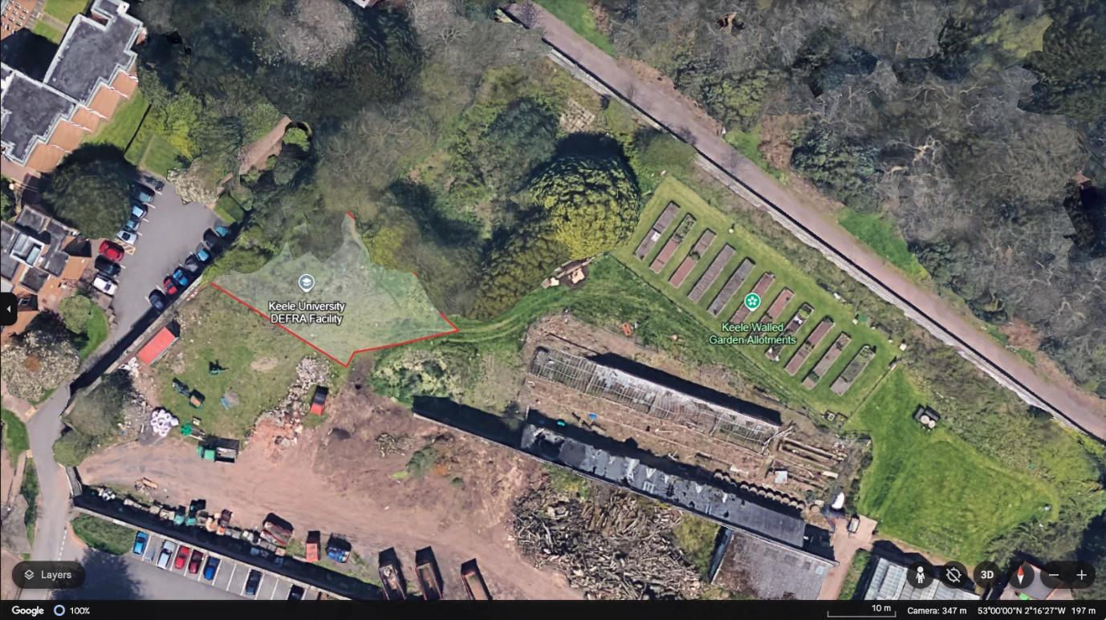

Figure 1: Overview of Primary Survey Area (KMZ file available on VLE)

Rationale for using Survey Area

The primary survey area has been identified by Keele University as a potential area for a mass grave. This is in a gated secure area with little footfall, with some nocturnal animal activity observed by campus safety personnel.

Hours of Daylight

During the time of survey sunrise is at ~8am and sunset is at 6pm. During the field work period work on the site will be limited to a short 3h time period. The working day can be shortened/cancelled at any time at the discretion of the course leader if the conditions are not suitable to continue working (for example very inclement weather).

Expected Weather Conditions

Springtime in the UK can be very variable. Students working outdoors should have suitable warm and waterproof clothing for wet and cold conditions. Equally weather conditions may be good, and students should be prepared for warmer conditions also.

Key Locations

Place | Coordinates | Address/Contact Details
Walled garden | ADD | n/a
Keele Practice | 53.002823, -2.287790 | Open Monday 08:00-18:00, Tuesday 07:30-18:00, Wednesday 07:30-19:30, Thursday 08:00-13:00, Friday 07:30-18:00,  Tel: 01782 753550
Well Keele Pharmacy | 53.001890, -2.271156 | Unit 4, Students Union Building, Keele University  Open Monday – Friday -08:30-17:30 Tel: 01782 633785
Hospital Accident & Emergency Department | ST4 6QG | Royal Stoke University Hospital, Newcastle Road, Stoke-on-Trent, ST4 6QG. Open 24/7  Tel: 01782 715444

Schedule of Operations - example

Day 1 –Reconnaissance

- Travel to survey area
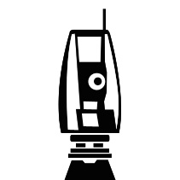
- Carry out site reconnaissance
- Carry out utility scanning (liaising with estates) to identify any issues/confirm infrastructure plans + metal detectors.
- Demobilise from survey area
- Charge equipment & back up data.

Day 2 – Survey Acquisition

- Travel to survey area
- Carry out UAV drone survey to obtain contemporary site photograph.
- Carry out surface surveying of any features of interest (e.g. suspected badger sett entrances, badger-related activity, survey grid extent).
- Carry out soil survey surface/auger (3 locations) to determine soil type(s)
- Demobilise from survey area
- Charge equipment & back up data.
- Process data to create site maps of survey area

Day 3 – Geophysical Acquisition

- Travel to survey area
- Carry out EM-31 Geophysical Prospecting looking for areas of interest for follow-up geophysical surveys.

- Carry out basic processing and contouring of EM-31 data to identify high priority targets and their coordinates.
- Carry out targeted GPR/electrical resistivity surveys at sub-areas using PulseEKKO Pro / Geoscan RM15D / CAMPUS TIGRE resistivity meter.
- Demobilise from survey area
- Charge equipment & back up data.
- Process geophysical data to create anomaly maps of survey area.

Day 4 – Intrusive investigation

- Travel to survey area
- Carry out careful archaeological investigations in the suspected mass grave site.
- Record and bag any remains and associated items of interest.
- Demobilise from survey area
- Charge equipment & back up data.
- Analyse recovered material in the lab and produce report

Field Methodology

UAV Drone Survey

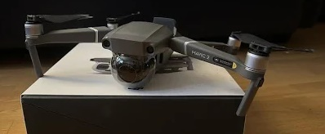
Figure 2: MavicPro UAV Drone

Key Objectives
- Acquire remote sensing data over survey area to provide sitemap / aerial view

Equipment
- Charged Mavic Pro UAV drone + spare batteries + controller
- Charged mobile phone + DJI Go4 app
- Take-off/landing ‘H’ panel

Hazards
There will be site hazards to the environment identified. Equipment and data are at risk from weather, above-ground objects, flat batteries and hardware failure. Operators must have A1 CAA printed FlyerID licence on person and must follow guidelines. For further details see associated risk assessment.

Methodology
- Place assembled UAV drone on landing panel, connect phone to controller, open DJI app, and start drone/controller (double-tap/hold on 2nd time).
- Fly to desired height to take image(s) and return following CAA guidance.
- If inclement weather/trees/people do not fly.
- Demobilise from survey area
- Charge equipment & back up data

CatScanner

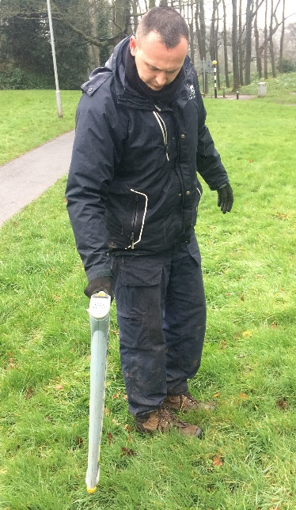
Figure 3: CatScanner 4 in operation

Key Objectives
- Locate any active underground utility/cables with obvious H&S risk for probing

Equipment
- SPX Radiodetection C.A.T.4
- Genny (if lifting inspection covers and clamping to extend detection range)

Hazards
There will be site hazards to the environment identified. Equipment is at risk from weather, above-ground objects, flat batteries and hardware failure. Operators must have appropriate training (KU estates (Grounds) team operating) and must follow guidelines. For further details see associated risk assessment.

Methodology
- Mark out survey area.
- Turn on CATscanner, adjust sensitivity knob and walk around area perimeter noting/marking where scanner emits audible noise indicating nearby conductive cable.
- Over audible area can sequentially raise scanner from the ground to estimate depth to target(s).
- If no cables detected can proceed with invasive geophysical (i.e. res) and soil (auger) surveys
- Demobilise from survey area
- Charge equipment

Soil Survey

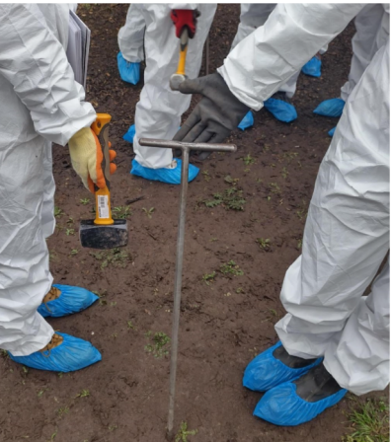
Figure 4: Soil auger

Key Objectives
- Acquire series of 1D soil auger information to confirm desk study survey area soil type(s)

Equipment
- 0.75m steel soil auger
- Lump hammer
- Soil information sheets
- Munsell soil color chart

Hazards
There will be site hazards to the environment identified. Cat scanner must be undertaken and sub-area(s) specified before survey commences. For further details see associated risk assessment.

Methodology
- Place auger vertically at desired survey position and hammer until auger inset is within ground. Slowly withdraw and twist to isolate soil core within auger.
- Inspect core to identify and record successive horizon boundary depth(s) & artificial/natural fragments.
- Determine horizon(s) color and texture using chart/sheets.
- Clean and redo (3 = 70% site variability, 5 = 90%)
- Demobilise from survey area.

Metal Detector Survey

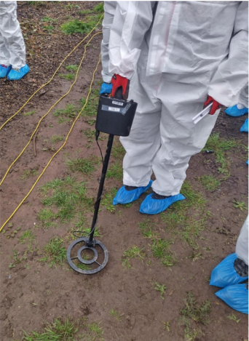
Figure 5: Metal detector

Key Objectives
- Locate any near-surface (<1m) isolated conductive object(s) within survey area. Do first and remove non-target objects before EM/magnetic surveys

Equipment
- Bounty Hunter Tracker IV All-metal detector

Hazards
There will be potential site hazards to the environment identified if locating bullet cartridges/UXOs. For further details see associated risk assessment.

Methodology
- Ensure switched on/assembled/configured (dials mid-ranges) and tested on object
- Divide up survey area and systematically traverse all areas
- Ensure continuous side-ways movements just above ground surface and re-check anomalous areas and mark/record if not immediately investigating source(s)
- Demobilise from survey area.

dGPS Survey

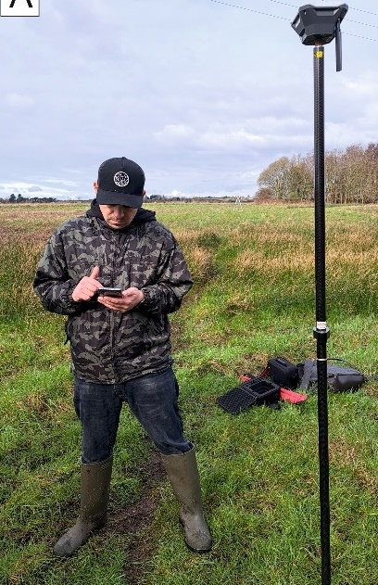
Figure 6: dGPS survey

Key Objectives
- Acquire accurate survey positions/points of interest

Equipment
- EMLID Charged Reach RS Rover & survey pole
- EMLID Charged Reach RS base, tripod and tribrach (if off campus)
- Charged mobile with Reachview App

Hazards
There should be no site hazards to the environment identified. Do check for overhead pylons, clear sky and rugged topography. For further details see associated risk assessment.

Methodology
- If off campus setup tripod, tribrach and base EMLID and use Reachview.
- Setup Rover EMLID on survey pole, use Reachview to survey points.
- Save project and associated survey points.
- Demobilise from survey area.

EM-31 Survey

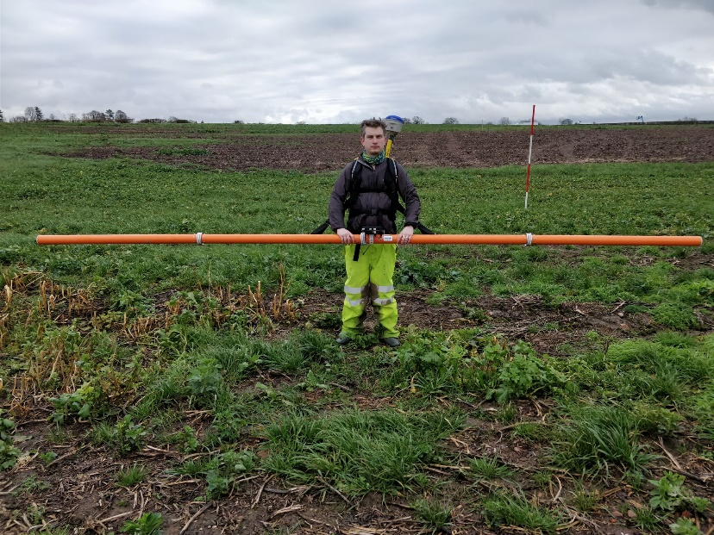
Figure 7: Electromagnetic Survey

Key Objectives
- Acquire conductivity data over survey area to aid identification of problematic areas for follow-up surveys.

Equipment
- EM-31D-Mk2 with charged ‘C’ cells + backpack with survey pole top
- Archer2 charged Data Logger
- Emlid Reach RS GNSS receiver with pole/screw mount
- Emlid Reach RS GNSS Base station (if off campus)
- Survey Tripod (if off campus)
- Tribrach with optical plummet (if off campus)
- Mobile device with Emlid Reach App

Hazards
There are no hazards to the environment identified. Equipment and data are at risk from weather, geo-magnetic storms, flat batteries and hardware failure. All metallic objects must be removed from the operator whilst collecting data. For further details see associated risk assessment.

Methodology
- Identify fixed calibration point in centre of the survey area.
- Configure Emlid Reach RS to output a NMEA GGA string at 10Hz over the serial into the Archer logger.
- Calibrate EM-31 over geophysically quiet survey area to zero
- Collect data at appropriate 1/4 target spacings in a undirectional grid using the track maker software to ensure coverage.
- Back up data from Archer and Demobilise EM-31
- Perform quick processing within ArcMAP to identify targets for subsequent survey.

GPR Survey

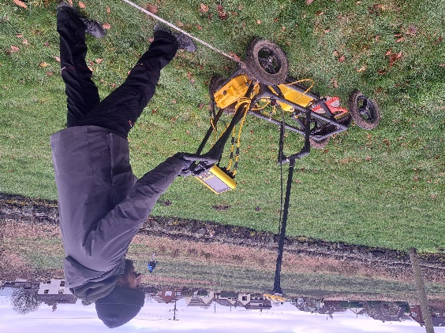
Figure 8: GPR Survey

Key Objectives
- Acquire GPR data over survey area to detect and quantify anomaly(s) presence/depth within survey area.

Equipment
- PulseEKKO Pro cart, DVI logger, GNSS GPS & accessories
- 12v charged leisure battery in pelican case + spare
- Set multi-frequency shielded antennas (250, 500 & 1000 MHz)

Hazards
There are no hazards to the environment identified. Equipment and data are at risk from weather, active EM transmitters (e.g. mobile calls), flat batteries and hardware failure. Check surface survey area for large objects to avoid/move if necessary. For further details see associated risk assessment.

Methodology
- For small sites set up survey profile lines, for large areas navigate to survey poles marking lines as data GPS tagged/5th trace.
- Boot up DVI logger (B) on connected PEPro cart, check configured for antennas, empty folder for survey data and scope mode calibrated recorded arrivals. Collect 1 file per profile line.
- Perform quick field interpretation using logger to identify anomaly(s) positions and flag/paint if necessary.
- Back up data and Demobilise GPR survey.

Resistivity CST ‘Zimmer Frame’ Survey
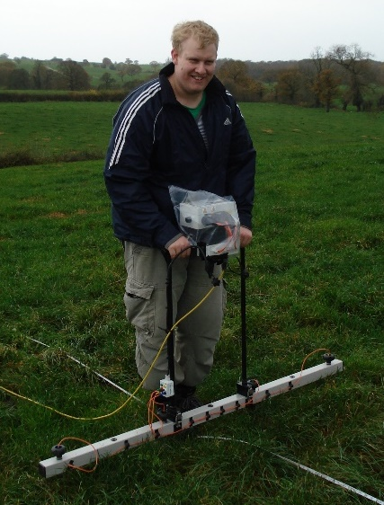
Figure 9: Resistivity CST Zimmer Frame Survey

Key Objectives
- Acquire fixed-offset CST resistivity data over survey area to locate near-surface buried feature(s) of interest.

Equipment
- Geoscan RM15-D charged resistivity meter (8 x spare AAs). Note can collect multiple depths using multi-probe mobile array and configured meter
- Geoscan remote probes (2) & electrical cable connecting wires

Hazards
There are no hazards to the environment identified. Equipment and data are at risk from weather, active cables, flat batteries and hardware failure. Check surface survey area for sub-areas where probes cannot penetrate the ground and revisit if significant. For further details see associated risk assessment.

Methodology
- Calculate survey area size to emplace remote probes so 30m cable reaches extents. Remote probes should be aligned to survey line direction and 10x probe separation, connected to mobile probes.
- Test equipment over survey area to ensure readings aren’t ‘Over Range’, widen remote probe separations to lower resistance if necessary
- Configure RM15-D grid & survey setup to replicate survey being collected, delete any previous dataset and ‘start’. Delete individual points if errors or dummy log if cant obtain reading. Press ‘finish line’ for each survey line.
- When survey complete, finish grid.
- Back up data and Demobilise RM15-D.
- Download using Geoplot software (needs dongle) & perform quick field processing to identify target(s).

Resistivity ERT Survey

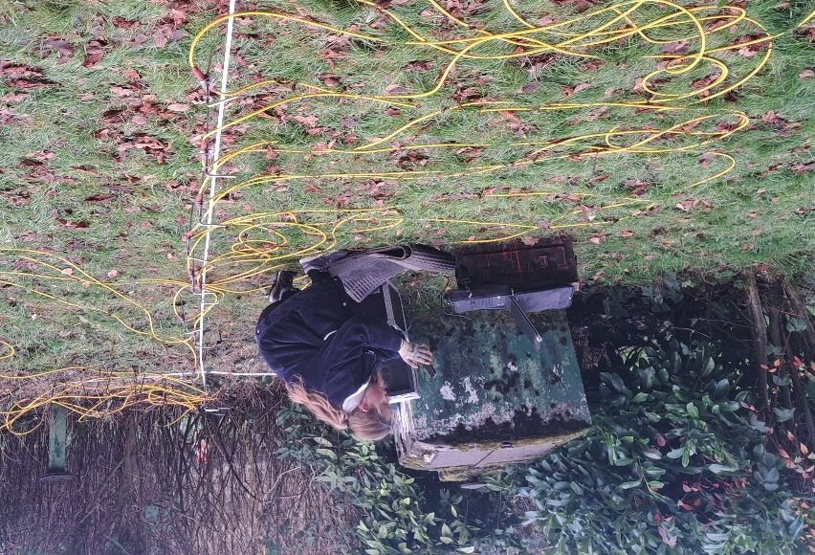
Figure 10: Resistivity ERT Survey

Key Objectives
- Acquire ERT resistivity data over identified anomaly within survey area to characterise.

Equipment
- Campus TIGRE charged resistivity meter
- 32/64 steel probes and cables
- 12v charged leisure battery
- PC charged laptop1 and power convertor

Hazards
There are no hazards to the environment identified. Equipment and data are at risk from weather, active cables, flat batteries and hardware failure. Check surface survey area for sub-areas where probes cannot penetrate the ground and revisit if significant. For further details see associated risk assessment.

Methodology
- Orientate profile line to centre and bisect anomaly(s) of interest. Set out probes and connect with cable & TIGRE/laptop.
- Connect equipment, use ImagerPro2006 and configure survey, test probe contact resistances and move laterally if anomalous
- Collect resistivity, when complete save (*.res/*.dat) dataset
- Back up data and Demobilise ERT survey.
- Download & perform quick field processing using Res2Dinv to identify target(s).

Abbreviations

Abbreviation/Acronym | Meaning
UAV | Unmanned Aerial Vehicle
GPR | Ground Penetrating Radar
CST | Constant Separation Traversing
GNSS | Global Navigation Satellite System
dGPS | Differential Global Positioning System
ERT | Electrical Resistivity Tomography
GCP | Ground Control Point
CAA | Civil Aviation Authority
FTW | Fit To Work
MS | Method Statement

Method Statement Register

This register should be initialled each day of survey prior to carrying out any fieldwork. Please sign to acknowledge that you are fit to work (FTW) and have read and agree to the method statement (MS).

Table 1: Method Statement Register
Date | Person 1 |  | Person 2 |  | Person 1 |  | Person 1 |  | Person 5
Date | FTW | MS | FTW | MS | FTW | MS | FTW | MS | FTW | MS

Date | Person 6 |  | Person 7 |  | Person 8 |  | Person 9 |  | Person 10 |  | Person 11
Date | FTW | MS | FTW | MS | FTW | MS | FTW | MS | FTW | MS | FTW | MS

Table 2: Please print name next to person number used in table above.
Person 1
Person 2
Person 3
Person 4
Person 5
Person 6
Person 7
Person 8
Person 9
Person 10
Person 11

