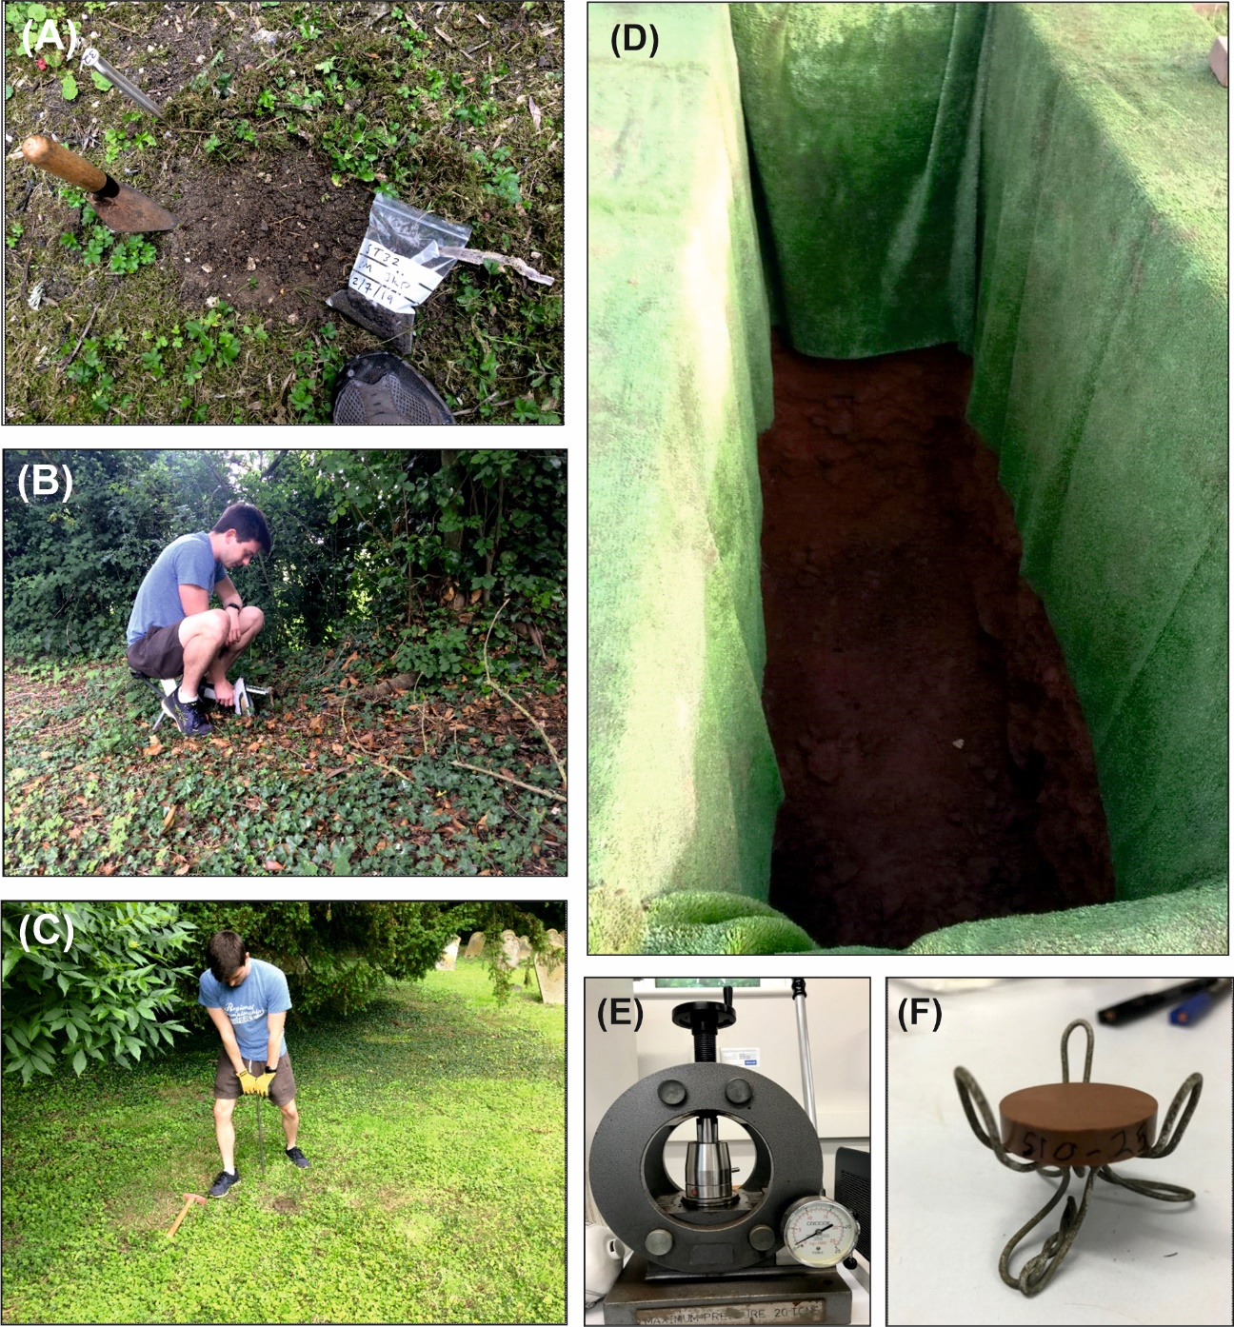
Figure S1. (A) selected sample location with overlying vegetation/pebbles cleared and sample bag shown. (B) Field pXRF 120 s analysis of a sampled surface graveyard soil location. (C) 0.75 m soil auger used 3x at each location to collect 0-25cm, 26-50cm and 51-75cm depth ranges soil samples. (D) pre-dug grave that was able to be sampled every 0.25 m down to 2 m bgl. (E) 20 Tn soil press used to produce (F) soil pellet, see text for details.

